2-Way Comm Payload

- Contains:
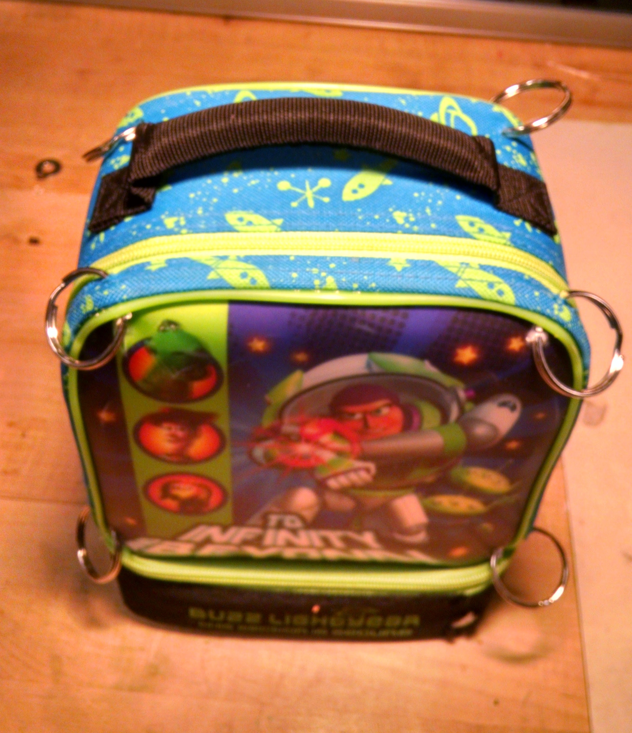Illustration 1: 2-Way Comm Payload Package
  - Payload Transceiver Module in top part
  - Payload Antenna in bottom part
  - RG-316/SMA interconnection cable
  - Support structure.
- Independent payload, ideally at bottom of platform with any APRS or other multi-Watt antennas as far away as practical.
- Attached to payload above it with four cords provided in the flight kit (see below) and a 50 lb zip tie at each of the eight connections.
- Once assembled, it need only be opened twice: Once to activate with the ON/OFF switch prior to launch and again to inspect and de-activate upon recovery.
- When fully charged, will last for 5+ hours.

NOTE: DO NOT REMOVE THE SD CARD
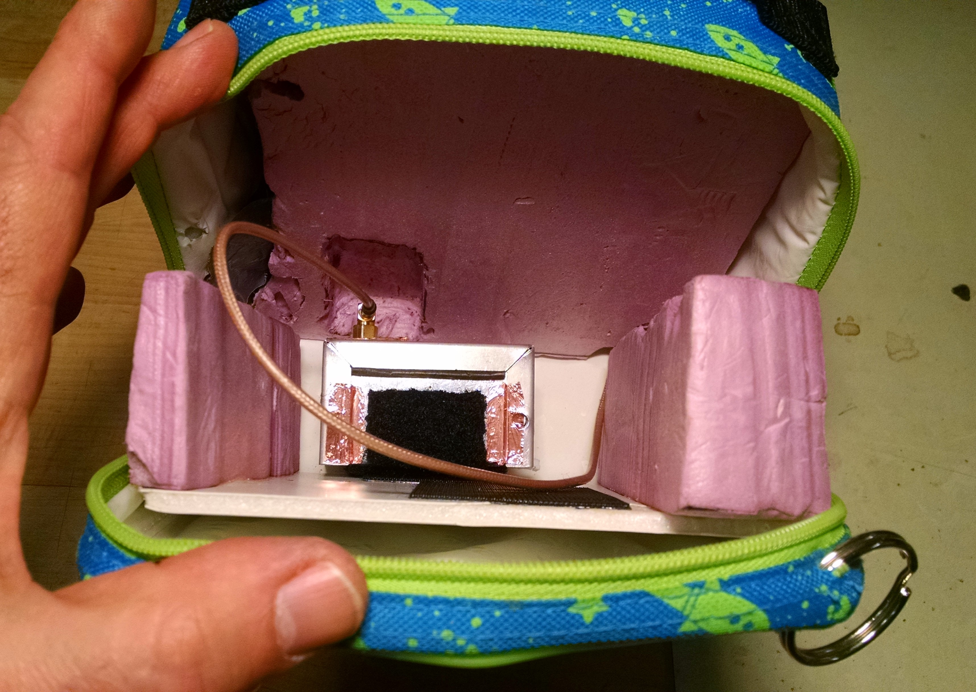Illustration 2: Top Section with Payload Transceiver Module

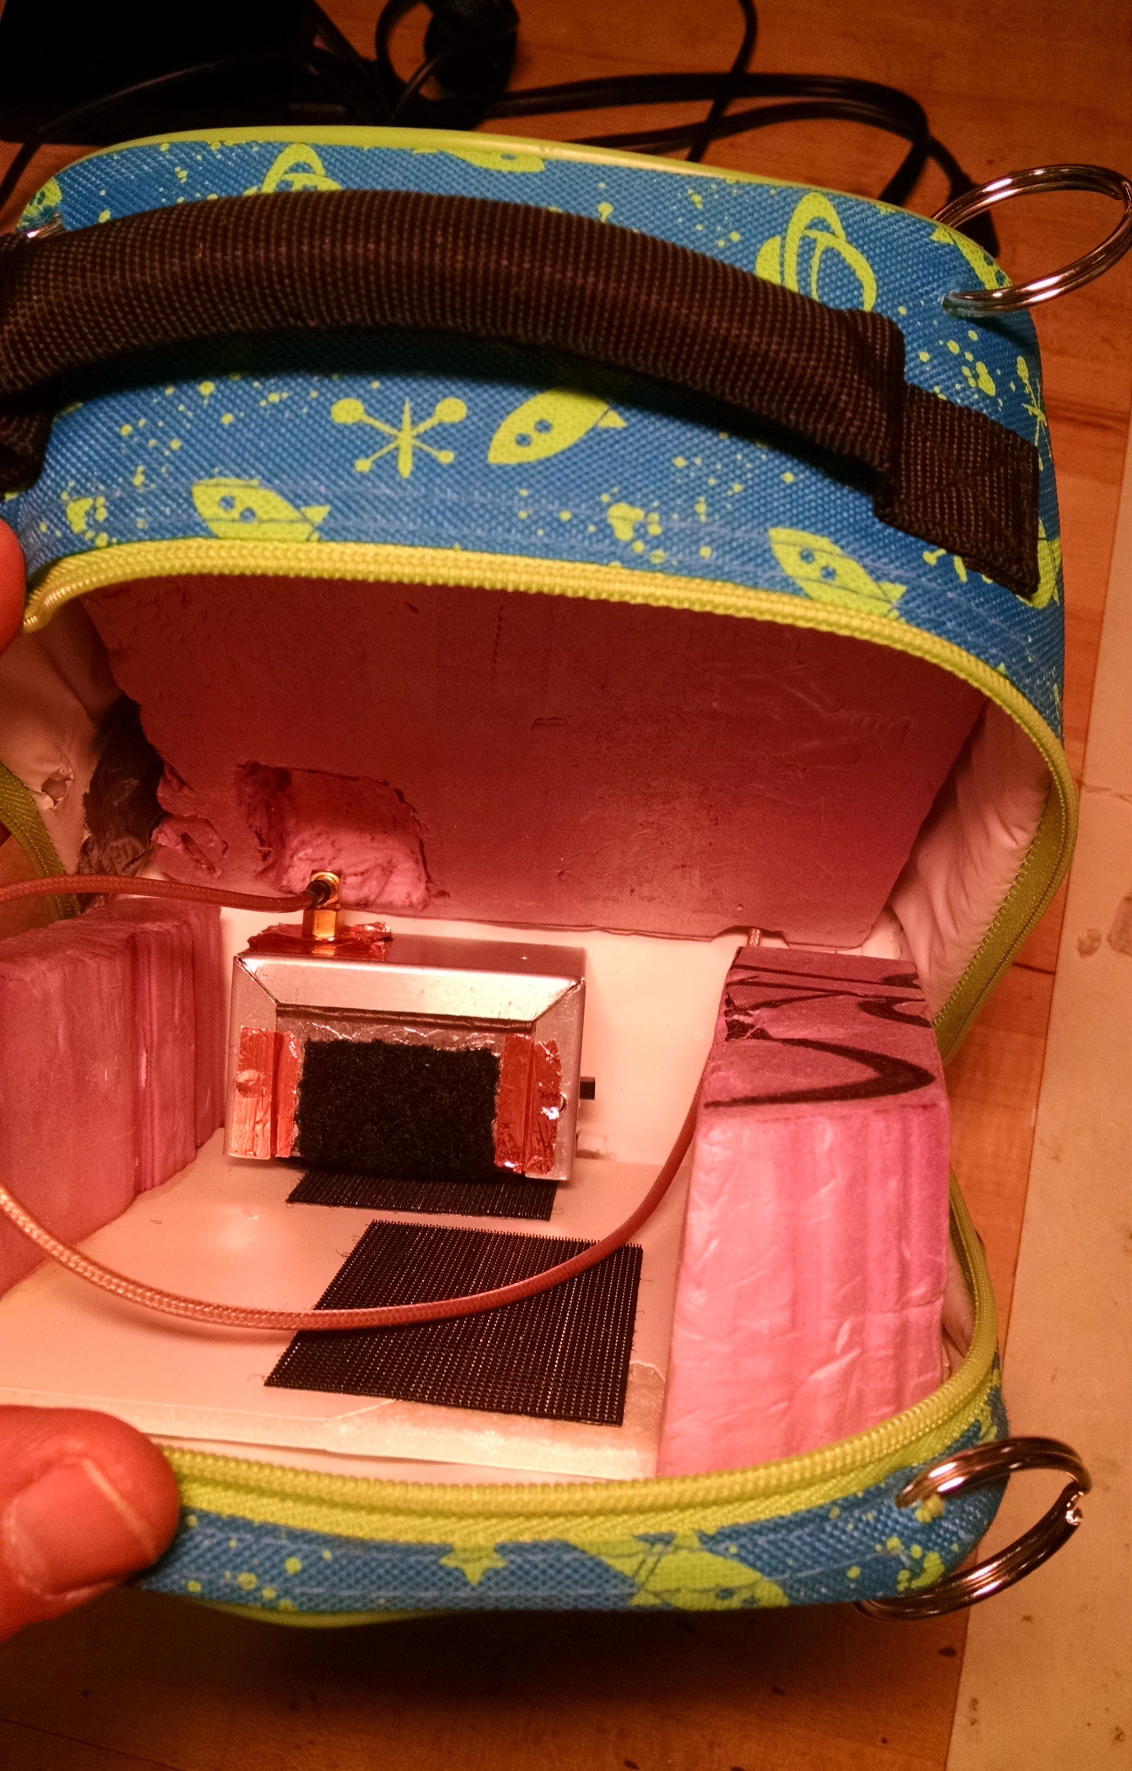Illustration 3: ON/OFF Slide switch on side of Payload Transceiver Module. Slide toward bottom to switch ON.
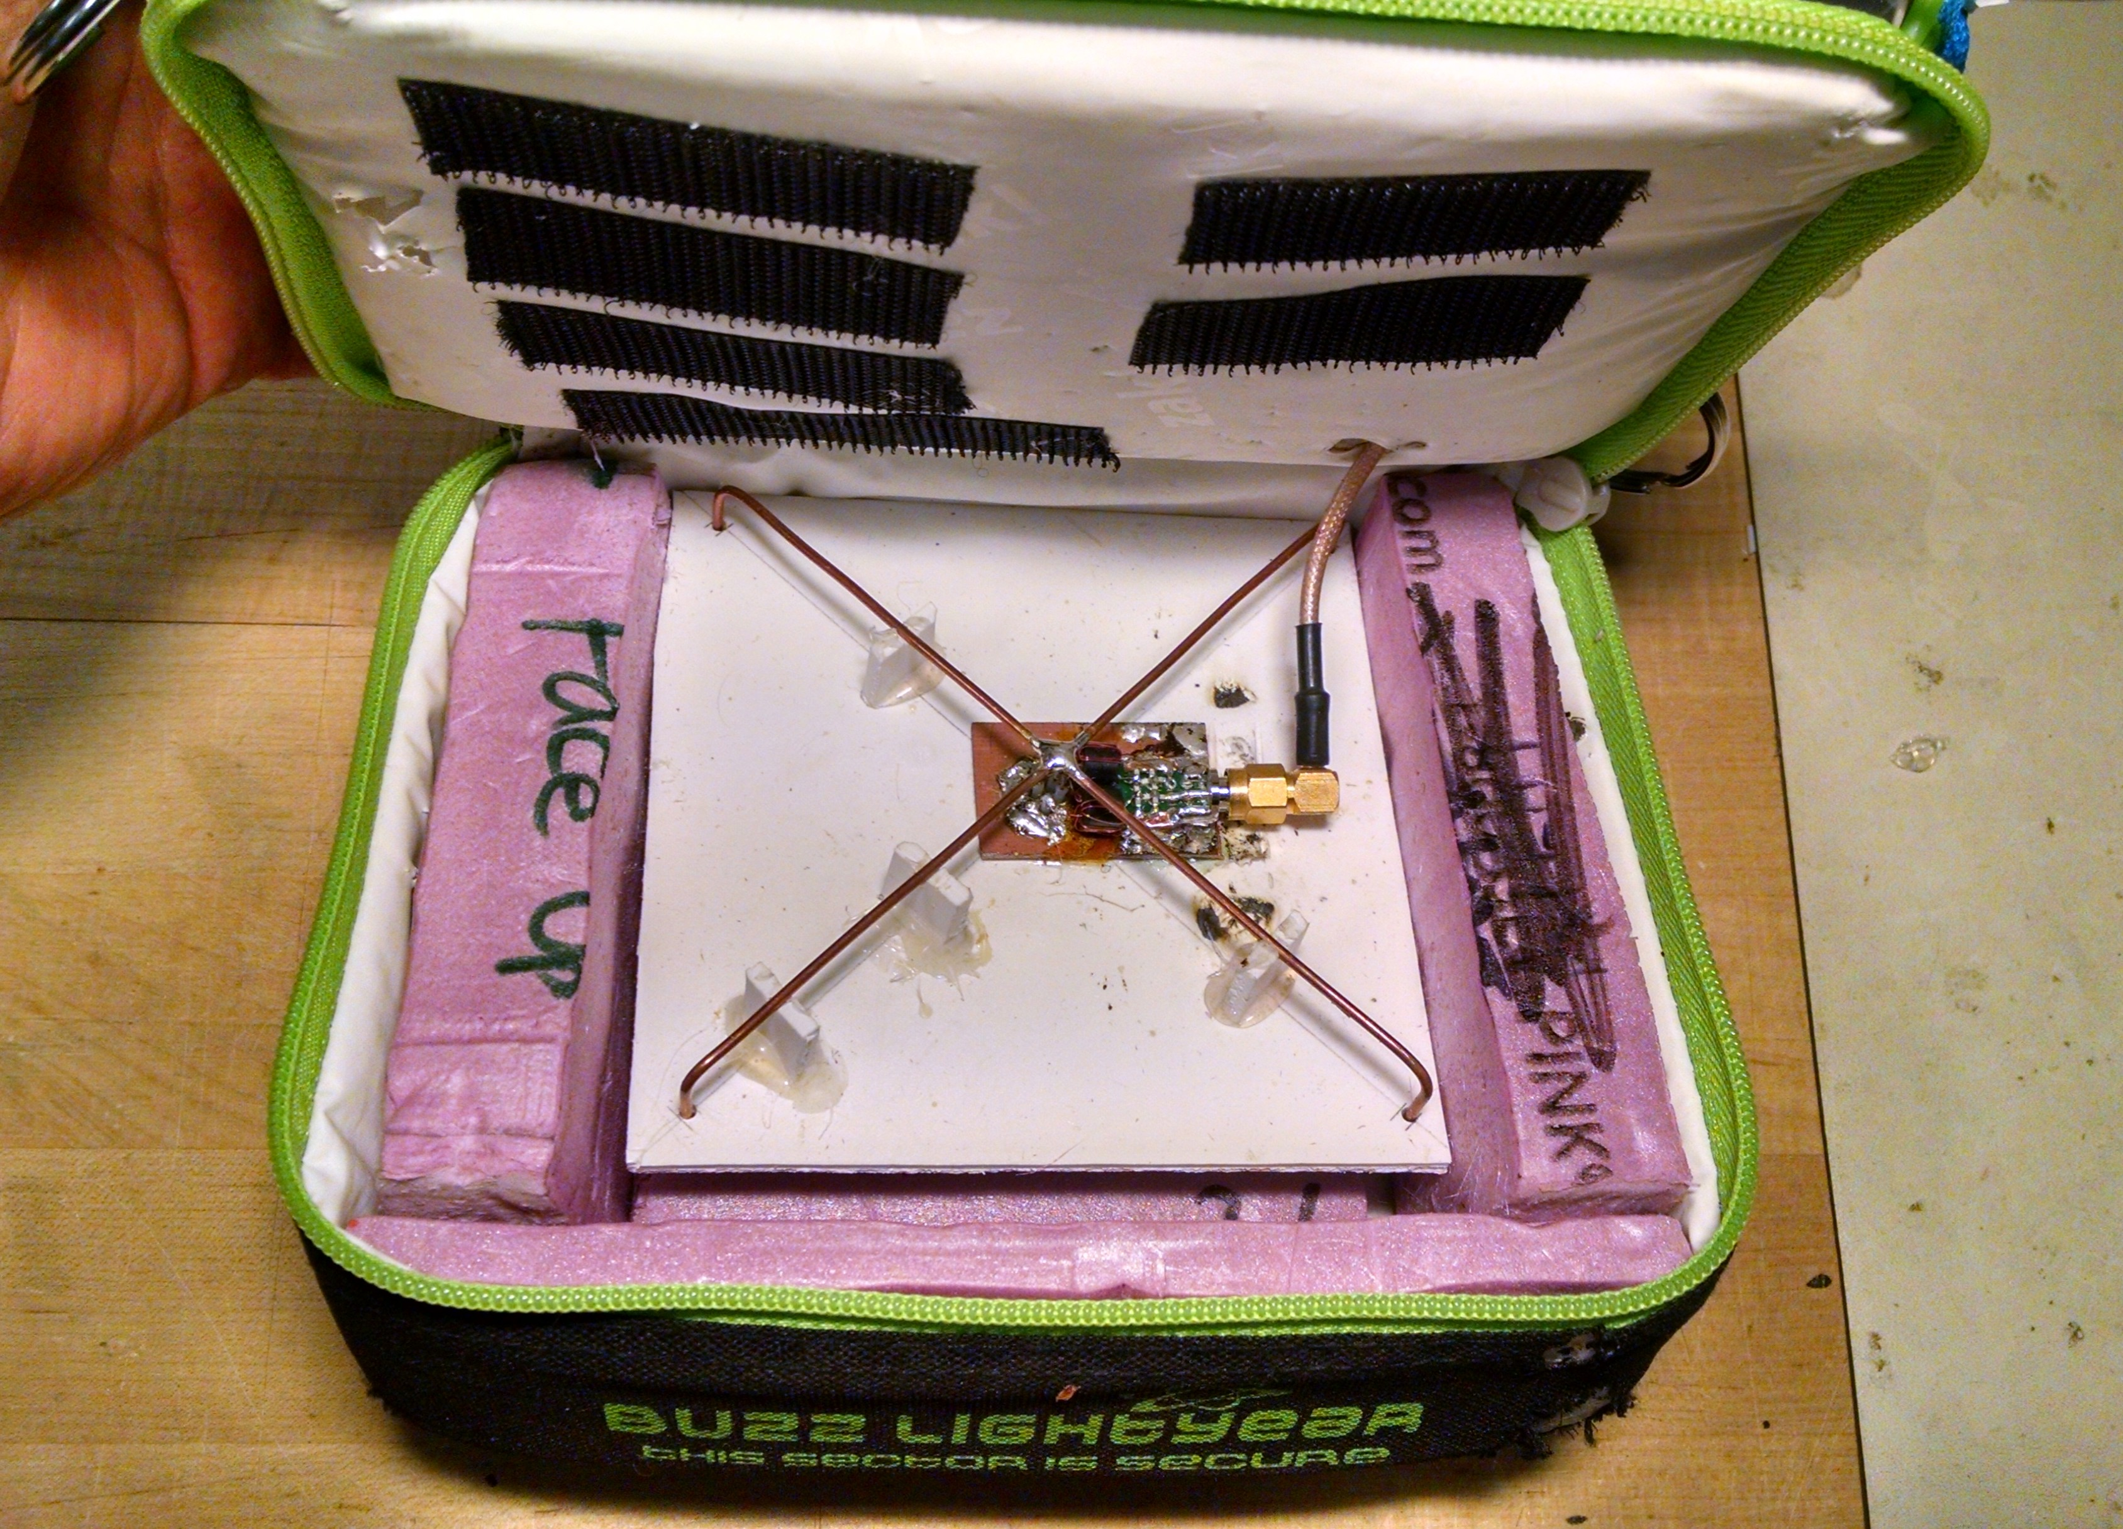Illustration 4: Bottom Section with Payload Antenna
2-Way Comm Ground Station
- Magnetic mount rooftop antenna.
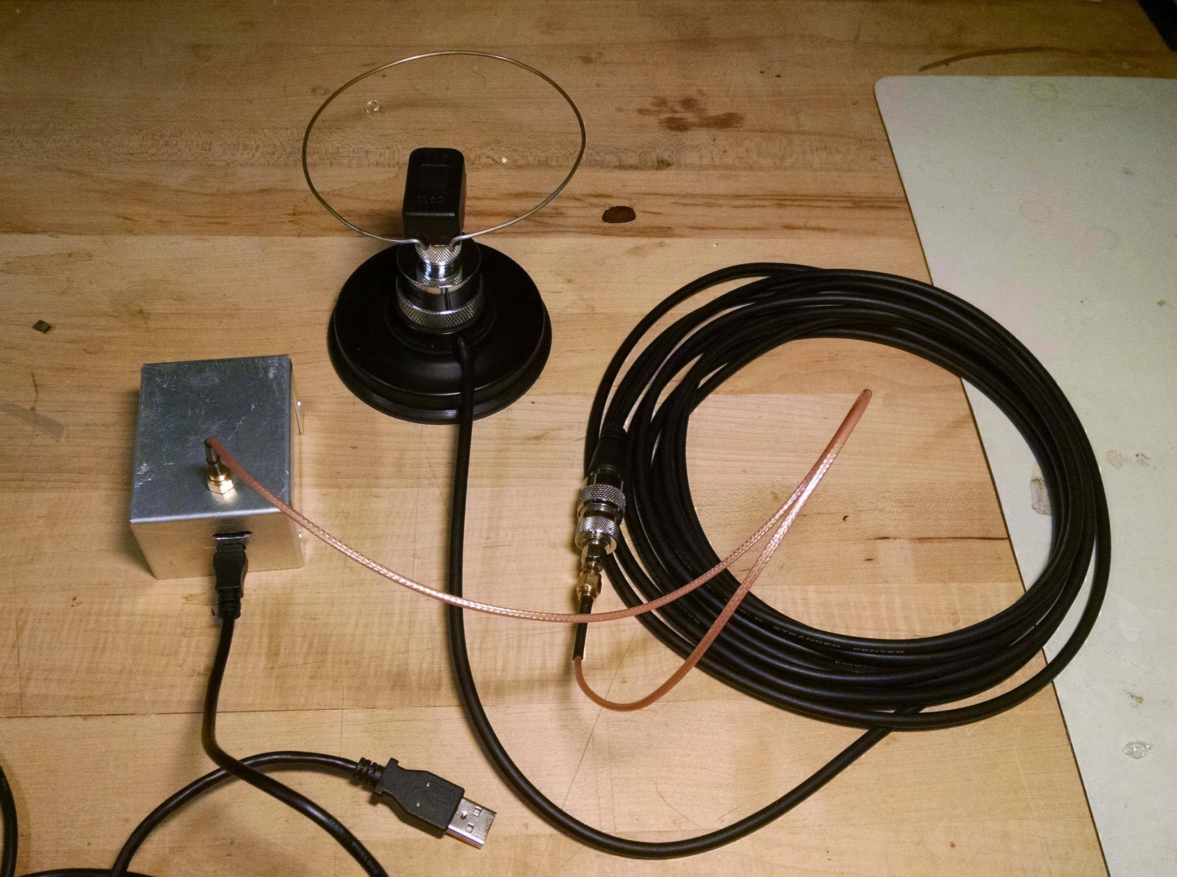Illustration 5: Ground Station components connected. Loop
  - As far from APRS antenna as practical.
  - Flat-ish metal within 0.5m radius.
  - Loop assembly screws attaches to base via integral UHF type connector.
  - Loop assembly must not be stressed! Handle using connector, NOT loop!
  - Connector-side of loop toward front of vehicle.
- Long base cable with adapter and pigtail passes through window or door.
  - AVOID pinching the cable!
  - Connects to Ground Transceiver Module
- OPTIONAL USB connection for serial terminal display.
NOTE: DO NOT REMOVE THE SD CARD
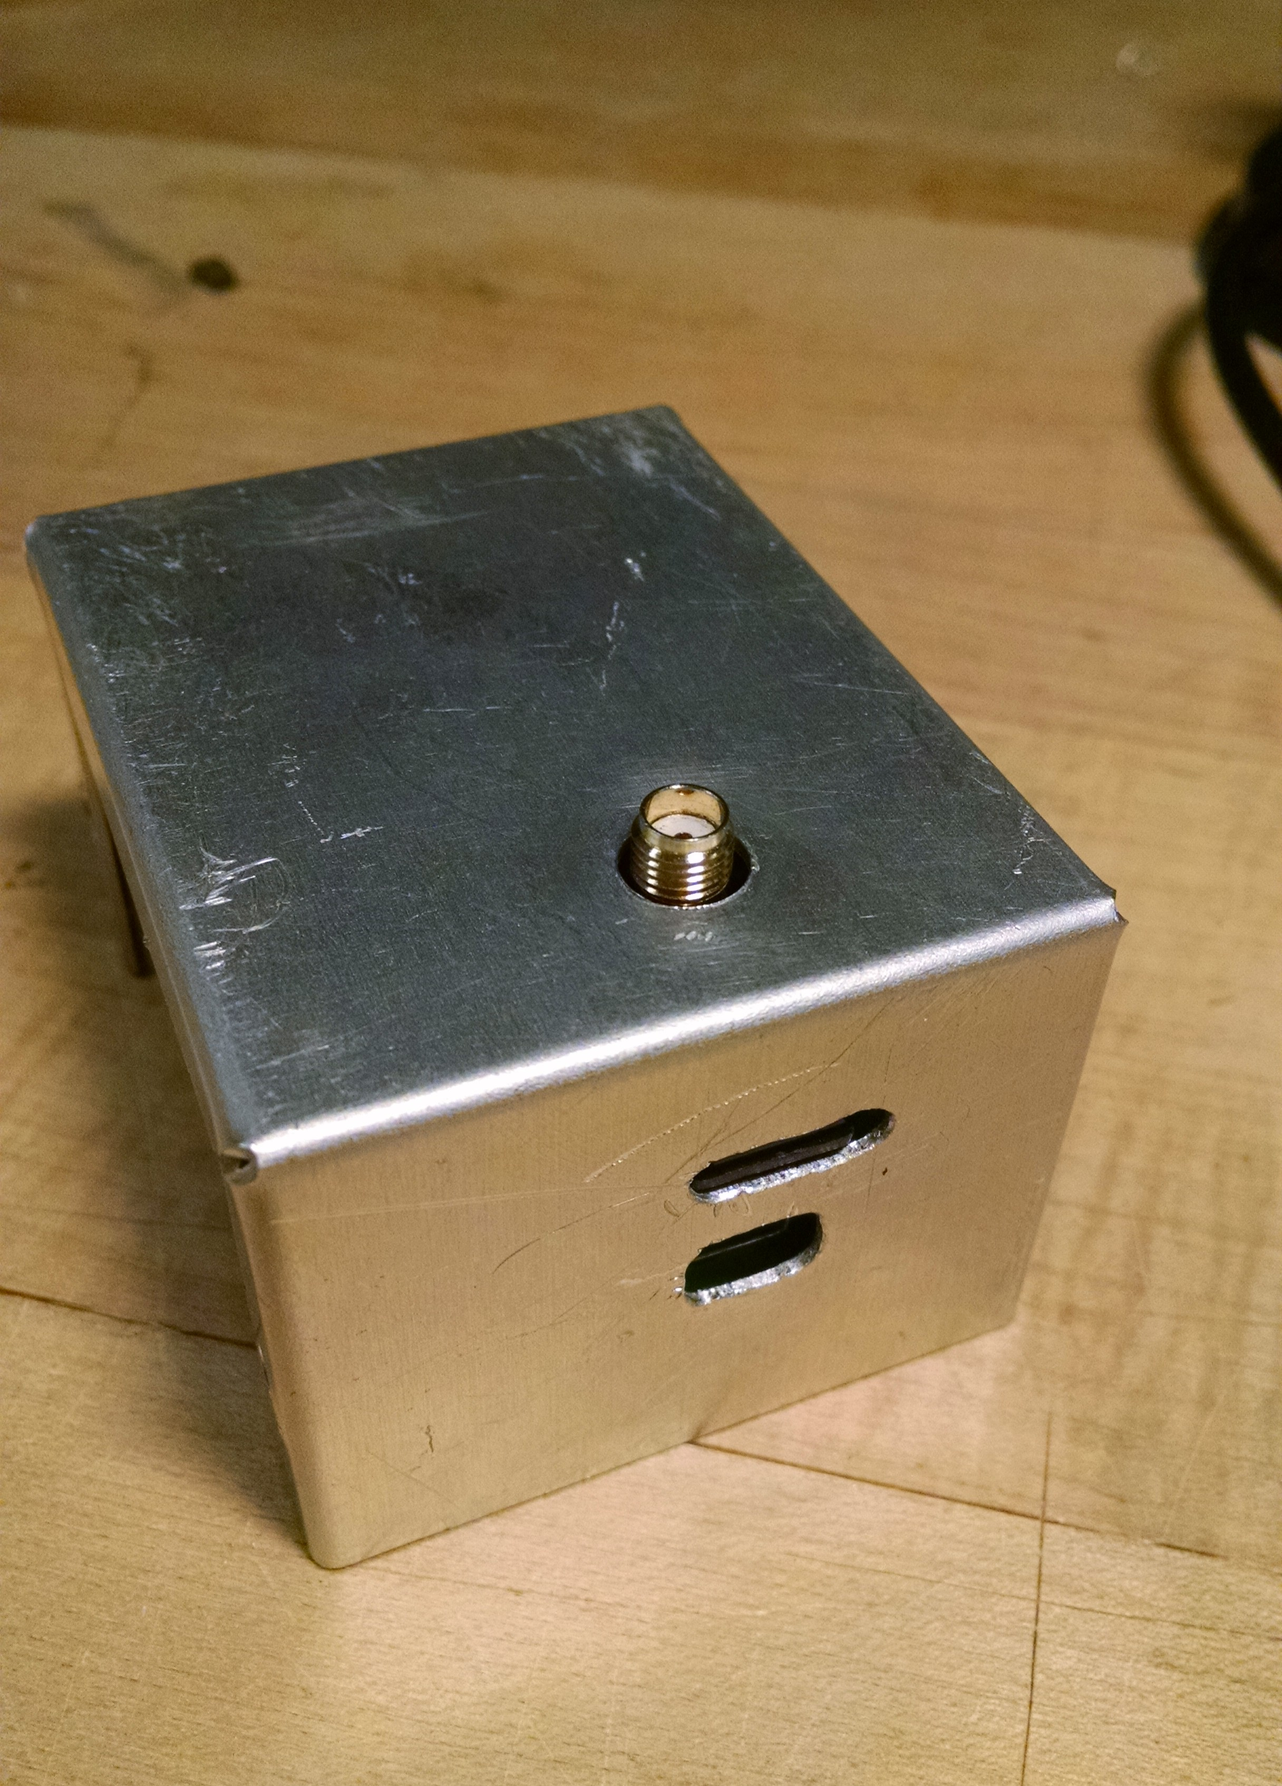Illustration 6: Ground Transceiver Module: A) OpenLogger SD Card slot. B) USB Connector for serial monitoring. C) SMA Antenna connector.
B
C
A
B
A
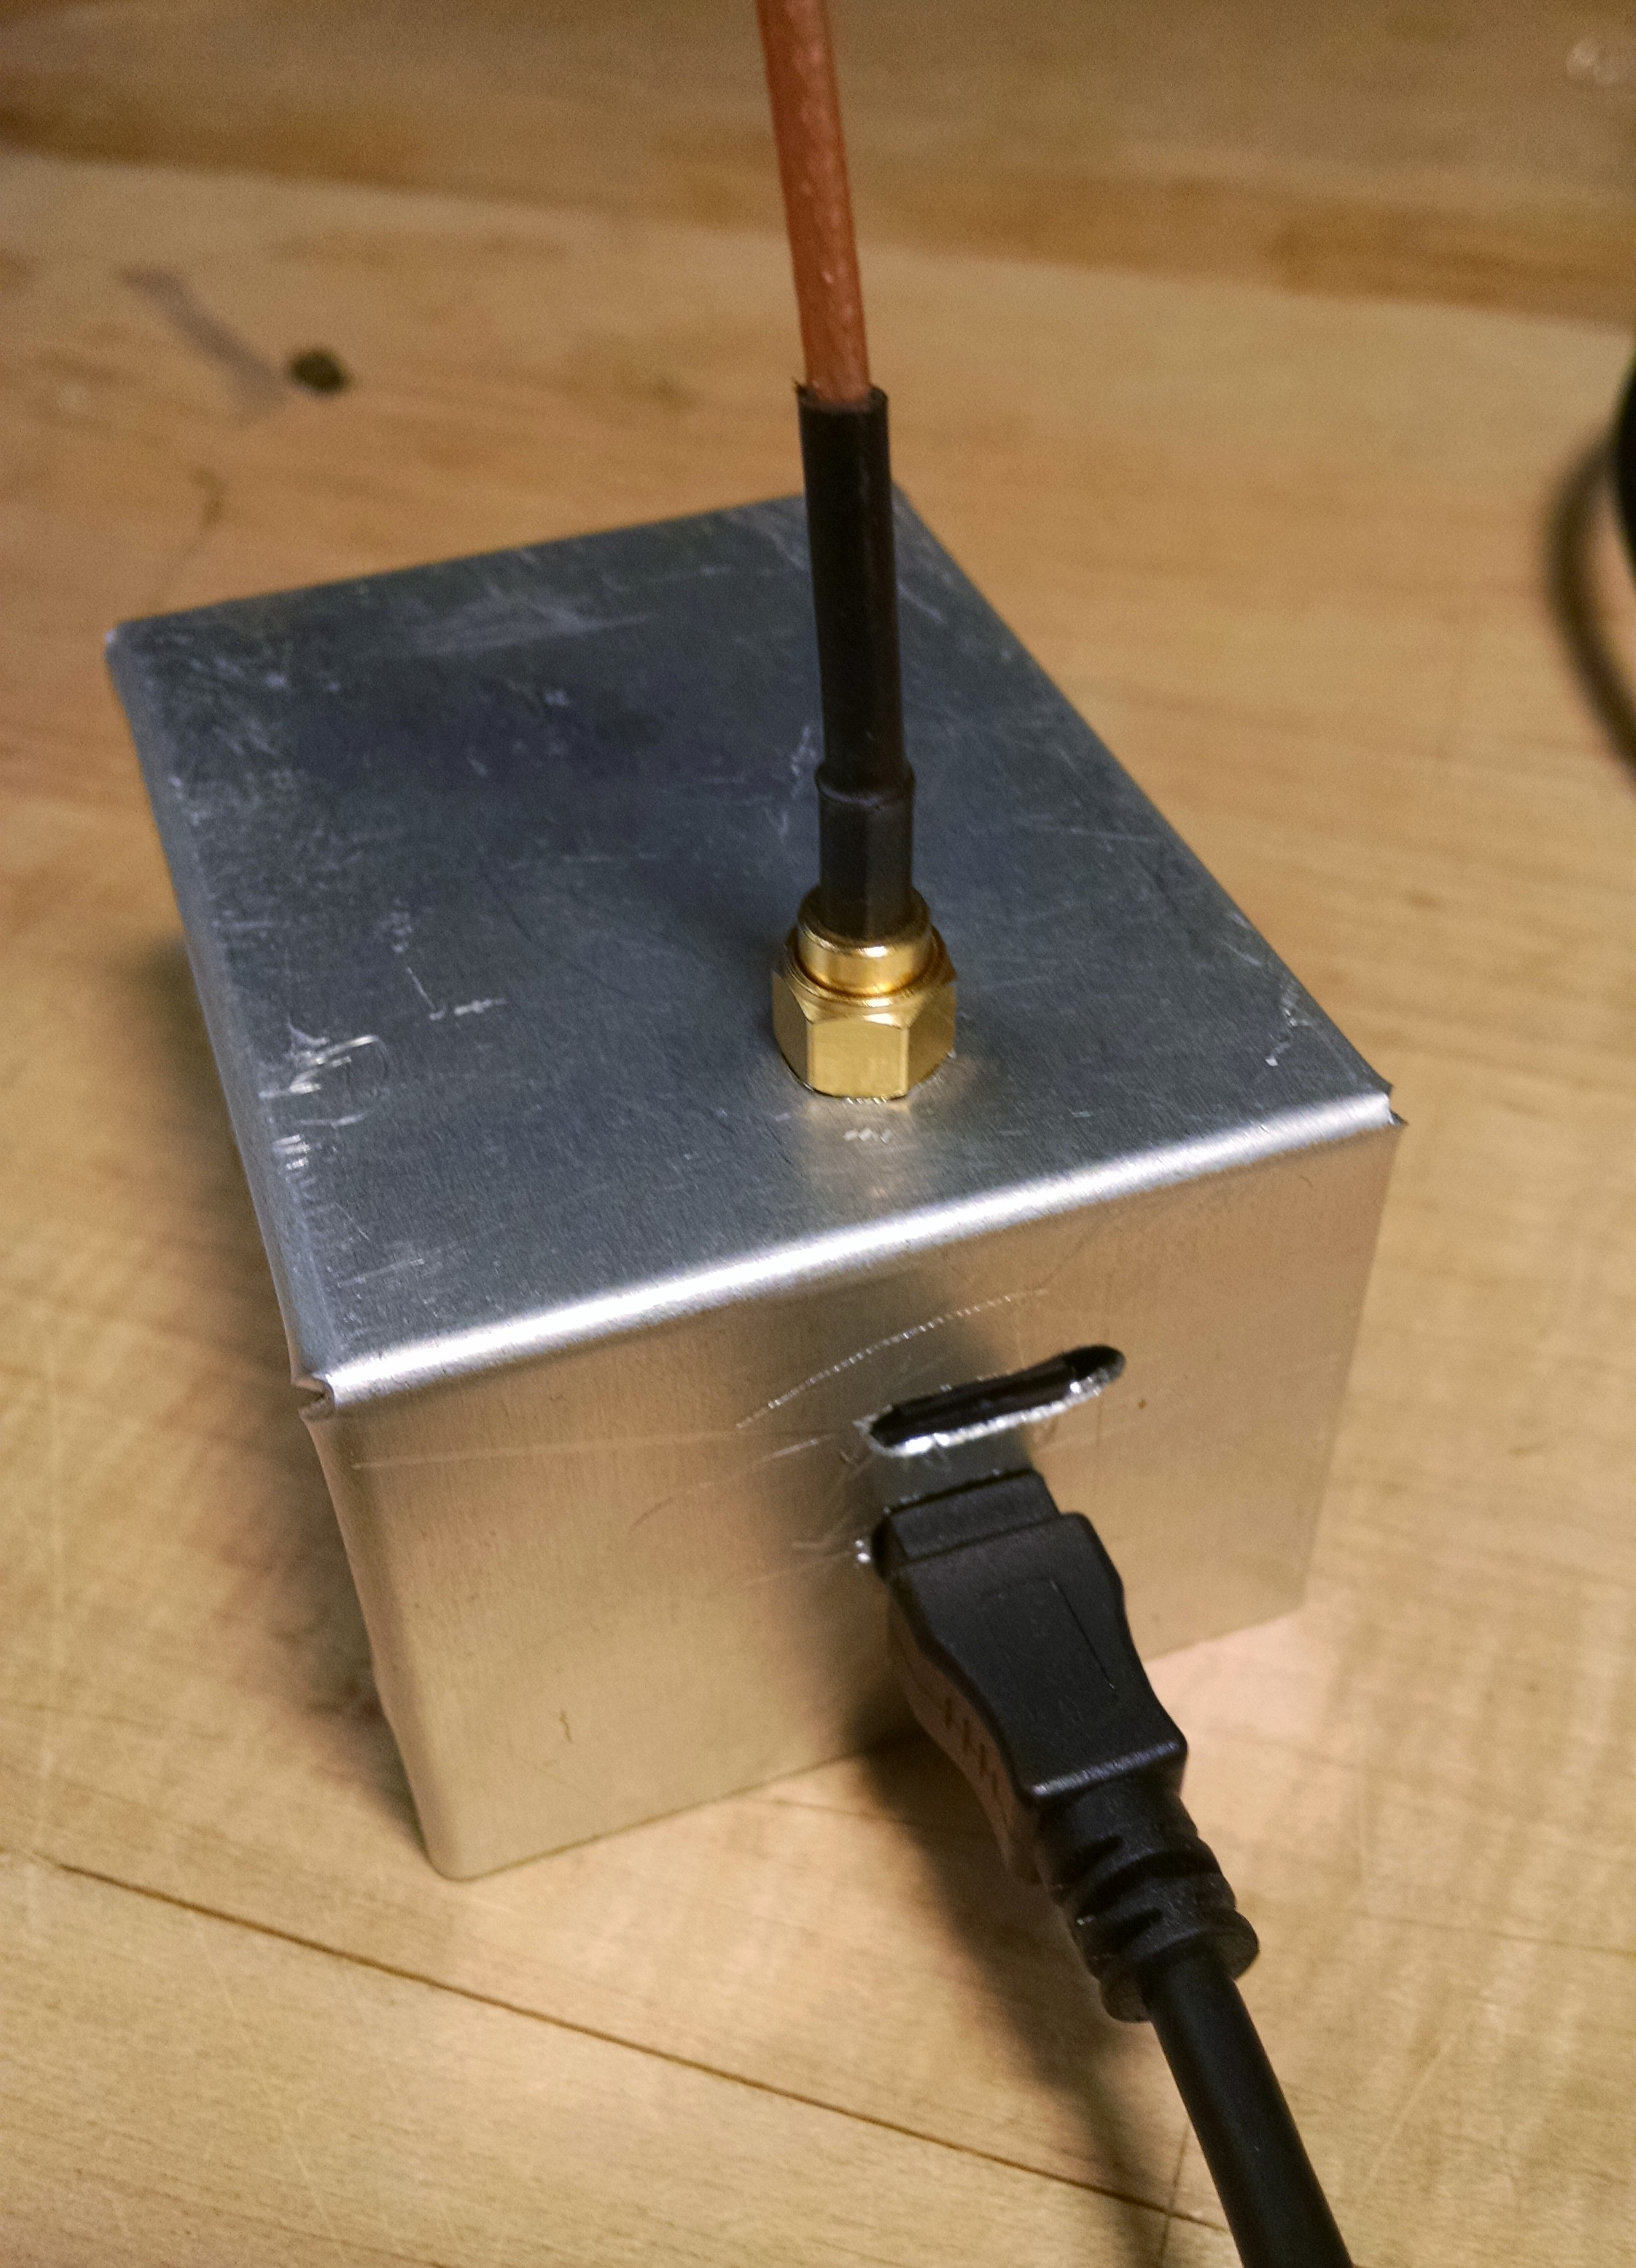Illustration 8: Connected Ground Transceiver Module. NOTE; RF connector nut should enter the case and not hang up at edge of hole.
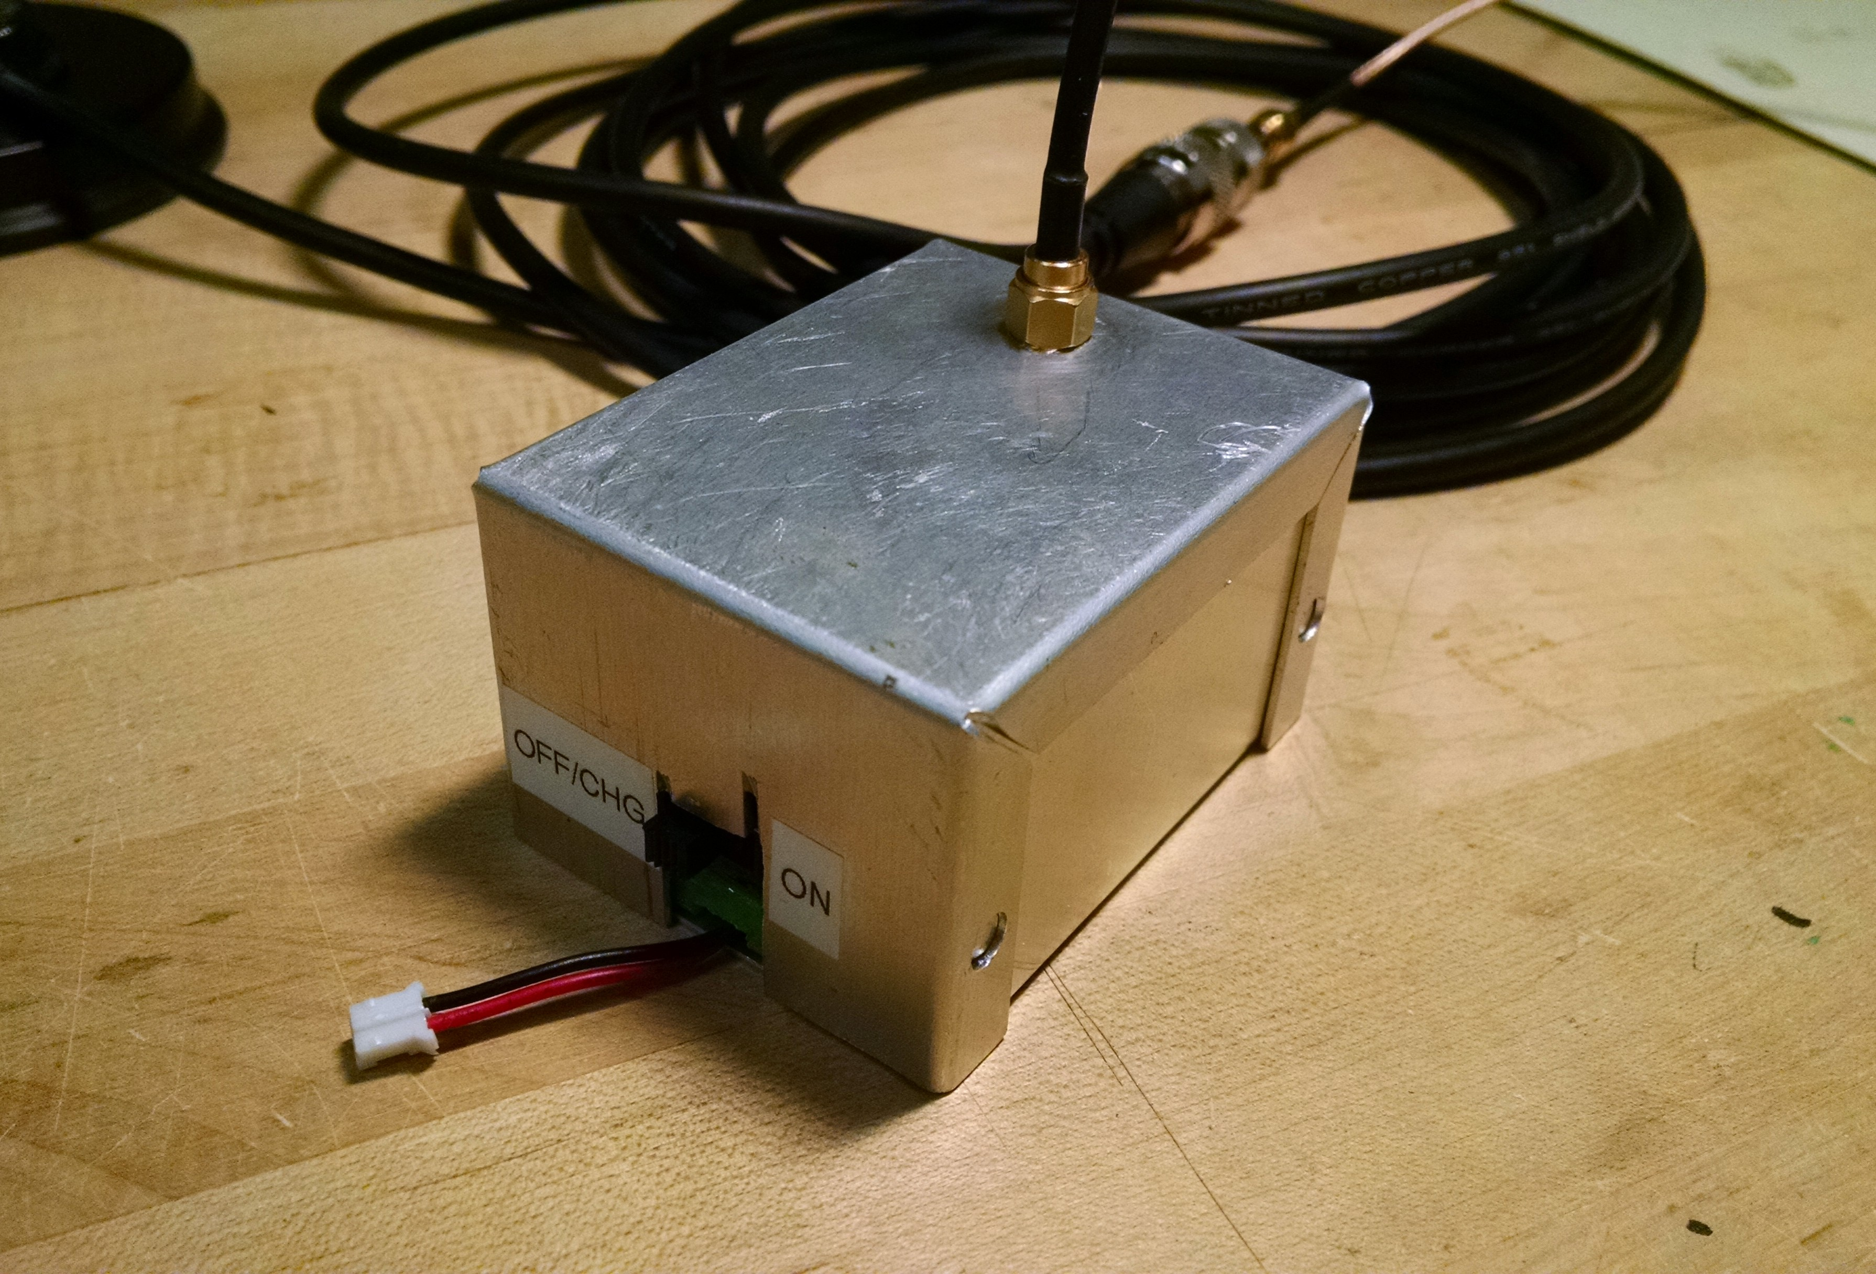Illustration 9: Ground Transceiver Module showing A) ON/OFF slide switch, and B) charger connection. When in OFF position, it can be connected to a proper LiPo charger (no other type allowed!)
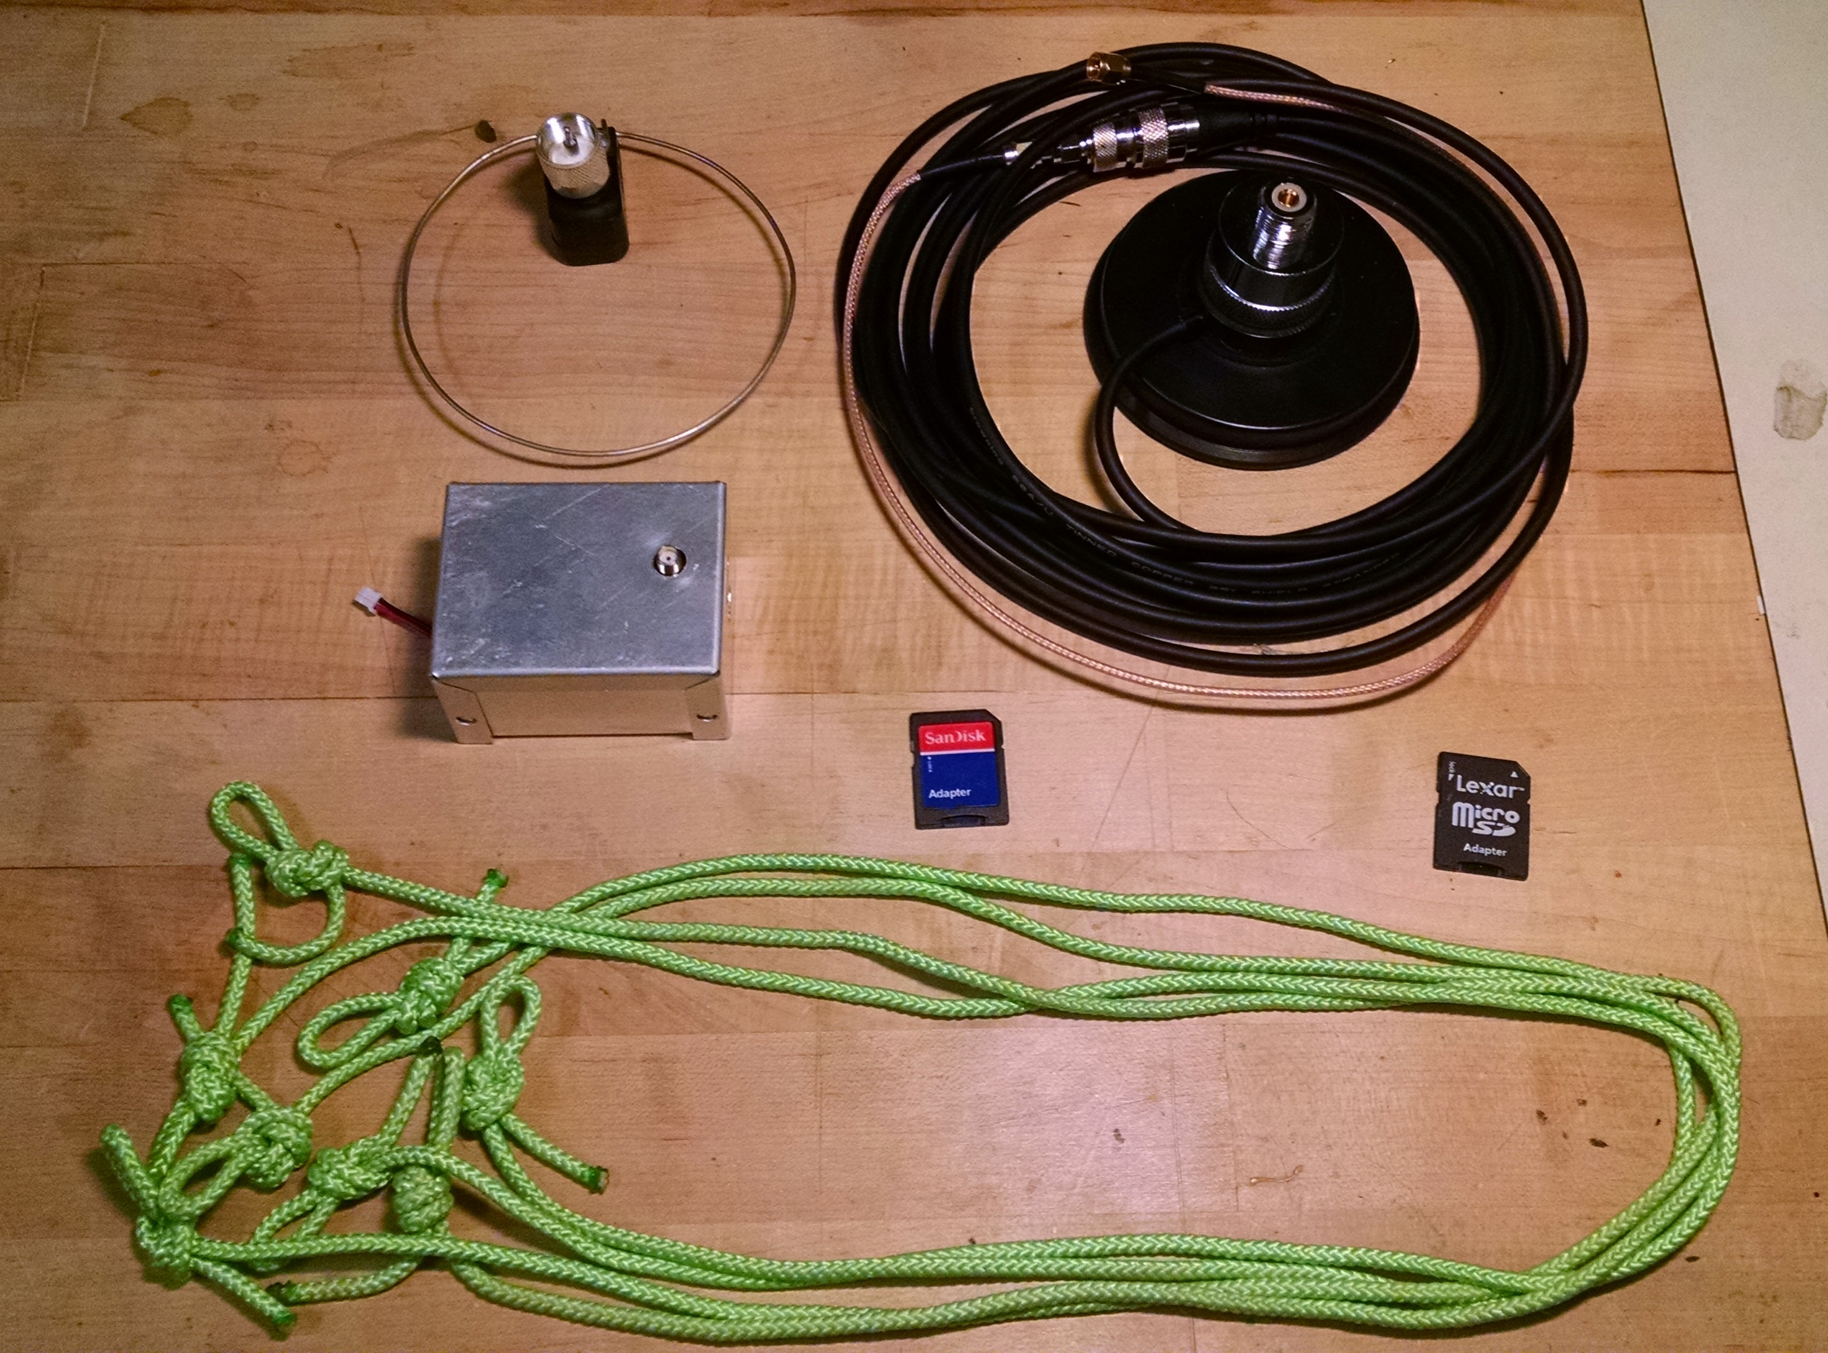Illustration 7: 2-Way Comm Flight Kit contents
2-Way Comm Flight Procedure
Launch:
The payload package should already be configured, assembled and inspected prior to leaving Adler according to the flight preparation procedure.
- INSPECT:
  - Open the compartments to inspect 2-Way Comm payload package to see if everything is in place and connected. Do not remove anything just to inspect, only to fix something that appears out of order.
  - Gently check to see if the RF connectors are loose and tighten with your finger. Don't loosen them by checking too vigorously.
  - Zip the package back up for now.
- SET UP GROUND STATION SYSTEM IN CHASE VEHICLE:
NOTE: with or without the optional PC connection, the Ground Transceiver Module will log the same information that would be displayed by the PC.
  - Attach antenna to rooftop (see the description above for important details).
  - Route cable with pigtail through window or door opening to interior (see the description above for important details).
  - Attach SMA pigtail connector to Ground Transceiver Module (see the description above for important details).
  - OPTIONAL PC CONNECTION if pre-flight test or monitoring during chase is planned:
    - Connect USB cable to Ground Transceiver Module and to a computer with Arduino IDE or an independent serial communication terminal app that works with a USB serial connection.
  - Activate the Ground Transceiver Module by sliding the ON/OFF switch to ON
  - IF OPTIONAL PC CONNECTION:
    - Start Arduino IDE or serial comm app, connect to serial port and open the serial terminal window. (if Arduino you don't need to open any software and DON'T CLICK THE UPLOAD BUTTON! – you only need the serial monitor window.
    - You may not see any output at this time, but the terminal should be active, waiting for a signal from the Payload Transceiver Module before it produces output upon responding.
- Open the 2-Way Comm payload package top portion.
- Prepare to note AND RECORD the time, to within a few seconds, at which you actually activate the Payload Transceiver Module in the next step. This is extremely important for syncing logged data with the ground station log and also to the balloon altitude later.
- Reach in and with a push of your finger, slide the Payload Transceiver Module switch downward to activate it. NOTE AND RECORD the time of activation accurate to within a few seconds.
- Close the payload package and set it down on its side so that the bottom (antenna) can freely radiate.
- IF OPTIONAL PC CONNECTION:
  - Check the serial monitor window on the ground station PC in the vehicle. Every 5 seconds, it should produce two lines of output similar to the sample shown below. The first line shows:
    - How many payload packets it has missed since the last one it received. The first entry can be ignored
    - The payload transmit packet index which cycles back to zero after 255.
    - The RSSI (Received Signal Strength Indicator) for the payload packet in dBm.
    - The payload transmit packet message:
      - Call sign
      - Rrrr where rrr is the negative value of the RSSI for the last ground transmitter packet received by the payload receiver.
      - T(-)ttt where ttt is the payload module temperature in degrees C x 10.
      - Lxx.. where xx.. is up to four digits of the measured light level inside the payload module.
  - NOTE: When the ground station transceiver power is cycled, when the USB is unplugged or plugged in, the PC goes into and out of standby or hibernate, and if the serial terminal is closed and re-opened may all re-start the transceiver. Avoid any of these, especially turning power off and letting the PC go to sleep as it makes the logging very hard to synchronize! IF IF ANY OF THESE THINGS HAPPEN, PLEASE NOTE THE TIME AT EACH EVENT AS BEST YOU CAN!
  - OPTIONAL: Try a lame uplink command/response test:
    - In the terminal input, type the single character 1. Within 1 or 2 packets the terminal output will display an acknowledgment that it transmitted this command by printing “L1” after the call sign. (See the sample terminal output below about half way down)
    - Several packets later, the Lxx... message should indicate a much larger light level as the command turns an LED on inside the payload transceiver box. (Also shown in the output sample below).
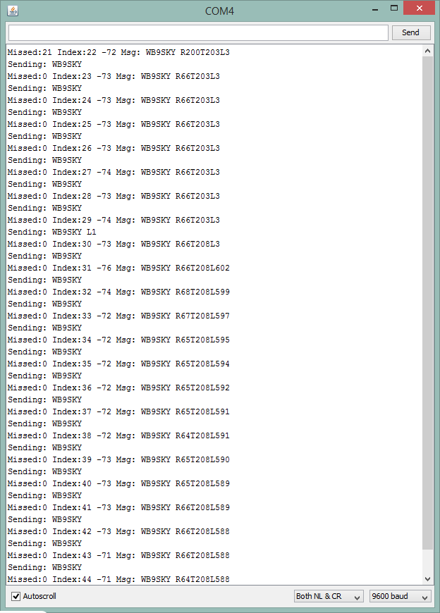
    - Sometime later, enter a single character 0 to turn the LED off and a similar thing will happen and the light level reported will go back down to a low level.
- Attach 2-Way Comm payload package to payload above it via the four cords provided using 50 lb zip ties at each connection.
- IF PC CONNECTION
  - If you're only monitoring for pre-flight checkout, you can disconnect the USB at this point but DO NOT TURN THE TRANSCEIVER OFF! Also, as noted above, please NOTE AND RECORD THE TIME OF THIS EVENT.
Recovery:
- As soon as convenient, inspect both compartments visually, but avoid handling any components. Just record observations of anything that appears unusual.
- Carefully reach in and slide the switch towards the top to turn the Payload Transceiver Module off.
- Close both payload compartments.
- Handle with some care and try to return the payload in the condition as found so we can do a post-mortem in the lab.
- Any time after the payload transceiver is turned off, you may turn the Ground Transceiver Module off and disconnect a PC if connected. DO NOT REMOVE THE SD CARD! That will be part of the post-flight analysis in the lab.

